<Cattle Weight Detection>

<Syed Aden Abbas>
< 25058978>
<May,2026 >

UFCEKP-30-3
Data science and AI individual project
Supervisor: James Barret


Abstract

Veterinary dosing, nutritional management, livestock trading all requires accurate cattle weight estimation, but existing approaches, such as mechanical scales and manual tape measurement, are laborious, time-consuming, and stressful to livestock. The present project looks into the possibility of accurately estimating live weights based on conventional RGB images, without specialized depth sensors or controlled imaging conditions.
An example YOLOv8n-seg instance segmentation model was fine-tuned on CWDM color-annotated cattle dataset to produce binary silhouette masks of side-profile images. The predicted masks were used to obtain morphometric features such as body length, estimated heart girth, bounding box dimensions, and pixel-area ratios, which were then used to estimate a Schaeffer formula. These measurements were combined into a twelve-feature vector and entered a Ridge regression model that was trained using GroupKFold cross-validation to avoid the leakage of animal-level data.
The last model had R 2 = 0.410 and MAE = 24.8 kg on the CWDM test set, which is significant compared to the Schaeffer formula used alone (R 2 = -0.120, MAE= 38.3 kg). The Schaeffer estimate was supported as the primary predictor by SHAP analysis (secondary contributions were made by heart girth and bounding box width). Although the error is limited by diversity in the breed and pixel ambiguity, the findings indicate that the low-cost, non-contact cattle weight estimation with the help of a mere smartphone camera is possible.

Acknowledgements
(Optional)

Table of Contents
Abstract 1
Acknowledgements 2
Table of Contents 3
Table of Figures 4
Chapter 1: Introduction 5
Chapter 2: Literature Review/ Industrial review 7
Chapter 3: Methodology/ Data sets selections and manipulation process 9
Chapter 4: Demonstration/ analysis 13
Chapter 5: Project Evaluation and Reflection/ Conclusion 22
References 23
Table of Abbreviations 25
Appendix A: Codes and Files 26
Appendix B: Supervisory meeting and emails. 27
Appendix C: ------ 28

Table of Figures
Figure 3.1 System pipeline from image capture to weight prediction
Figure 3.2 Sample CWDM colour-annotated images and corresponding segmentation masks
Figure 3.3 Morphometric measurement extraction showing body length and estimated heart girth
Figure 4.1 YOLOv8n-seg predicted instance segmentation masks on CWDM validation images
Figure 4.2 Schaeffer formula predicted vs. actual weight (R² = −0.120, MAE = 38.3 kg)
Figure 4.3 Ridge regression predicted vs. actual weight, colour-coded by error magnitude (R² = 0.410, MAE = 24.8 kg)
Figure 4.4 SHAP beeswarm plot showing feature importance for the ridge regression model

Chapter 1: Introduction

1.1 Background and Motivation
Proper estimation of livestock weight is vitally important to cattle farming - it guides feeding, drugs dosing, sales value and comprehensive health care of the herd. In smallholder farming environments, especially in Sub-Saharan Africa and South Asia, weighing scales are either inaccessible or unreliable or non-existent. Machila et al. (2008) observed that 85.7 percent of smallholder farmers in East Africa underestimated cattle bodyweight (average underestimation of 46.9) with only 19 percent of underestimates within the range of accurate dosage of veterinary drugs, a direct result of using unaided eye-judging to estimate weight.
Conventional alternative techniques, including the Schaeffer heart girth tape formula (Lesosky et al., 2012), involve physical contact with the animal and trained staff, which presents feasible limitations and safety hazards. Computer vision provides a non-invasive method: determining the weight by analyzing the images that are taken at a distance with the use of ordinary cameras. Recent progress in deep learning and instance segmentation has enabled extraction of body measurements with adequate accuracy in image to be used in downstream weight estimation. Nonetheless, most of the literature on high-performing systems use depth cameras, 3D scanners, or controlled enclosures (Xu et al., 2024; Liao et al., 2025) - hardware and infrastructure that cannot be utilized in low-resource field environments. This project examines the possibility of competitive weight estimation in the case of standard RGB images taken in the uncontrolled field environment, in the absence of depth cameras or animal recordings.
1.2 Problem Statement
The main problem is the problem of scale and measurement ambiguity. A regular RGB image does not give any metric information, the physical dimensions will have to be determined by the geometry of pixels with reference to a known standard. To make the matter worse, the livestock body dimensions useful to estimate their weight (heart girth, body length) are three-dimensional quantities that are represented by a two-dimensional silhouette, which causes systematic geometric error. The question that this project answers is whether enough can be done to ensure that this error can be reduced to yield practically useful weight estimates in field settings via meticulous extractions of measurements and a machine learning corrective layer.
Another problem is the generalisability of datasets. Most published livestock weight estimation models are conditioned on regionally-specific data with limited breed variety and prediction accuracies have been found to differ substantially across breeds despite employing identical measurement protocols (Tasdemir et al., 2011). It is possible that a model that has been trained on a single breed composition will not generalize to another, such that regional deployment will need either breed-specific training data or a model that is robust enough to tolerate cross-breed variance in a single pipeline.

1.3 Research Questions
This project addresses the following research questions:
- Can cattle live weight be reliably estimated from standard RGB images alone, without depth sensors or animal metadata?
- How reliably can the Schaeffer formula estimate cattle weight when applied to pixel-derived measurements from segmentation masks?
- How does a pixel-level segmentation approach compare to bounding box detection for body measurement extraction?
- Can a scale-based calibration method provide sufficient pixel-to-metric conversion for morphometric measurements?
- Does body-part segmentation improve weight estimation over whole-body silhouette approaches?

1.4 Approach and Contributions
The suggested system optimizes a YOLOv8n-seg model of instance segmentation using the CWDM (Cattle Weight Detection Model Dataset (Kaggle, 12K)) cattle dataset to identify pixel-level body silhouettes. Geometrically, morphometric measurements (body length and heart girth) are obtained based on the mask and transformed to physical units by a calibration sticker. An initial weight estimate is obtained using the Schaeffer formula and improved using a Ridge regression model that is trained using twelve mask-derived features. The pipeline is tested on GroupKFold cross-validation to avoid the problem of data leakage between images of the same animal.

1.5 Report Structure
Chapter 2 reviews relevant literature on livestock weight estimation and computer vision segmentation methods. Chapter 3 describes the system methodology in full. Chapter 4 presents and analyses results across all approaches evaluated. Chapter 5 concludes with a summary of findings and directions for future work.

Chapter 2: Literature Review/ Industrial review
2.1 Formula-Based Weight Estimation
The initial non-contact cattle weight estimation techniques were based on basic morphometric equations based on physical measurements. The Schaeffer formula, based on heart girth and body length to determine live weight, is still popular in the field as it is simple and does not need much equipment. Lesosky et al. (2012) confirmed the formula with specific references to East African shorthorn zebu cattle and determined its relevance in the CWDM dataset setting and the fact that heart girth is the best single predictor of weight in this breed group. Nevertheless, formula-based methods rely solely on proper physical measurement - Machila et al. (2008) show that human estimations of cattle weight in smallholder areas without the use of aids have an error or variance of 46.9 on average, which is certainly why objective, repeatable measurement techniques should be employed.
2.2 Image-Based Morphometric Measurement
The use of 2D digital imaging in extracting body measurements has been tested on various livestock species. Tasdemir et al. (2011) indicated that 2D image analysis was an effective measurement modality, as body measurements obtained using digital images of Holstein cows such as chest girth, body length, and wither height, could predict the live weight with R 2 =0.98 when the photographs were taken in controlled conditions. Bewley et al. (2008), applied this concept to body condition scoring of dairy cattle, reporting that anatomical landmark measurements based on 2D images were predictive within an error range of 0.25 BCS in 92.79% of the animals. More recently, a study by Özkaya et al. (2025) has attained R 2=0.92 when using body area measurements in RGB images taken during regular weighing procedures, which substantiates the idea that image-based morphometrics still perform well in-field, assuming that the camera geometry can be repeated.
2.3 Deep Learning Segmentation for Livestock Applications
Deep learning segmentation models have turned out to be of great benefit in enhancing body boundary detection in livestock images. Qiao et al. (2019) show that Mask R-CNN generates contour-level cattle masks that are much more conducive to morphometric measurement compared to bounding box detection, making instance segmentation the correct preprocessing stage of body measurement pipelines. Single-stage detectors have demonstrated benefits over two-stage methods in complex farm scenarios: Araoujo et al. (2025) find that YOLOv8 attains 89.8% mAP at 0.5 compared to 77.66 at Mask R-CNN, at a rate of nearly three times greater inference speed. This trend is verified by Sapkota et al. (2025) in the more general agricultural segmentation tasks, and in the latter case, YOLOv8 is shown to be better in accuracy and recall. All of this prompted the choice of YOLOv8n-seg as the backbone of the segmentation in this work.

2.4 Depth Sensor and 3D Approaches
The most effective livestock weight estimation systems that are described in the literature, use depth information. The article by Pezzuolo et al. (2018) involves the use of a Kinect depth camera to obtain body measurements of pigs, with R 2=0.89 without any intermediate step that relies on a formula. The ResNet-101-D semantic segmentation used by Xu et al. (2024) on depth images of cattle is combined with a backpropagation neural network, and the authors report R2=0.98 under controlled conditions in the barn. Liao et al. (2025) use YOLOv8m to segment depth images of dairy calves and get R 2=0.91. In all these works, depth sensing removes the scale-ambiguous aspect of RGB imaging by reconstructing metric body dimensions directly, so it is the most commonly used hardware in high-precision systems. The real obstacle is cost and infrastructure - depth cameras cannot be deployed in the field with limited resources.

2.5 Machine Learning for Weight Regression
In addition to formula-based and deep learning solutions, machine learning regression using extracted morphometric features have become an effective compromise. Oka et al. (2025) compare Ridge, Random Forest, CatBoost and polymer regression on body measurements of Bali cattle at various stages of growth and find that selection of models is dependent on the age of the animal and that ensemble approaches are more effective than linear models on mature animals. Zin and Tin (2026) place this body of work in the larger precision livestock farming paradigm, as they contend that computer vision in conjunction with machine learning allows shifting the paradigm of herd management toward the predictive approach. Gjergji et al. (2020) show that CNNs on dual-view RGB images in the field conditions attain MAE=23.19 kg - setting a realistic RGB-only benchmark that the given work specifically aims at reaching.

Chapter 3: Methodology/ Data sets selections and manipulation process
3.1 Pipeline Overview
The proposed system is a stepwise pipeline that includes image capture based on a standardized protocol, instance segmentation to isolate the silhouette of the cattle, morphometric feature extraction with a sticker-derived scale, the Schaeffer formula, and a machine learning correction layer trained on the extracted features. The pipeline can use standard RGB images with no depth sensor or animal metadata, which can be used with the RGB-only field methods studied by Gjergji et al. (2020) and Özkaya et al. (2025), which is also less constrained than their capture geometries, and also uses a less constrained capture geometry than either of these studies.
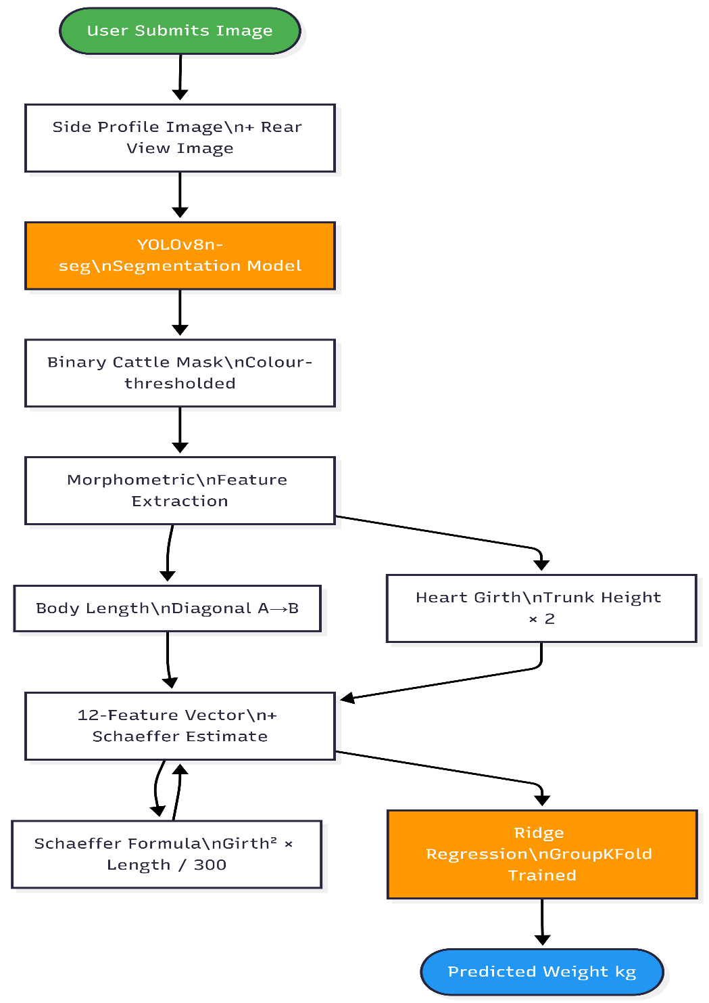
Figure 3.1: System pipeline from image capture to weight prediction

3.2 Dataset
This project used the Bill and Melinda Gates Foundation (CWDM) cattle data. The data is represented by about 1,500 annotated pictures taken out of two standardized positions, including side profile and rear view, of various breeds of cows, body conditions and outdoor lighting conditions. Annotations of each image are provided as a pixel-level color-coded mask of four regions: cattle body (RGB: 0, 255, 0), calibration sticker (RGB: 255, 240, 0), ground (RGB: 255, 0, 0), and background (RGB: 0, 0, 255). Each image was developed with a yellow 10x10 cm calibration sticker that was used to check the pixel to centimeter ratios and ensure that measurements were consistent across the dataset. A 80/20 train-test split was used, with the training images giving about 1 200 and the held-out test images giving about 300.
The pipeline was also tested on an independent set of unseen images that were not a part of the CWDM data. Proper predictions to such pictures proved that the pipeline generalizes outside the training distribution, when the standardized image capture protocol is observed. The animal is positioned so that the images are taken with this animal inside a given silhouette outline displayed on the capture interface, and the effective focal distance is fixed, and the measurements of the pixels are related to constant physical dimensions of all inputs - analogous to Tasdemir et al. (2011), who also defined metric scale using known reference dimensions with 2D
3.3 Segmentation Model
YOLOv8n-seg was chosen to be the backbone of the segmentation (Jocher et al., 2023). Instead of being trained on the CWDM training set, the model was fine-tuned, using the pretrained COCO weights (Lin et al., 2014) which already encode bovine morphology, so the model does not need to learn to recognize a cow by itself. Fine-tuning makes the model specific to the CWDM image conditions and annotation colour scheme. Training used default Ultralytics augmentation with random horizontal flips, mosaic composition and scale jitter. YOLOv8 has demonstrated superiority over Mask R-CNN in terms of accuracy and inference speed when used in agricultural segmentation tasks (Sapkota et al., 2025), and in particular in challenging farm settings with cattle (Araaujo et al., 2025), where mask quality is directly connected to downstream measurement accuracy.
At inference, thresholding of pixels with a tolerance of 15 RGB units of each annotation colour is used to decompose the predicted segmentation mask to allow JPEG compression artefacts. Instead of bounding boxes, pixel-level instance masks are employed because contour-level segmentation yields much more valid morphometric measurements (Qiao et al., 2019). The output binary mask of cattle generates all the downstream measurement steps.
Figure 3.2: Sample CWDM color-annotated images (top) and corresponding segmentation masks (bottom)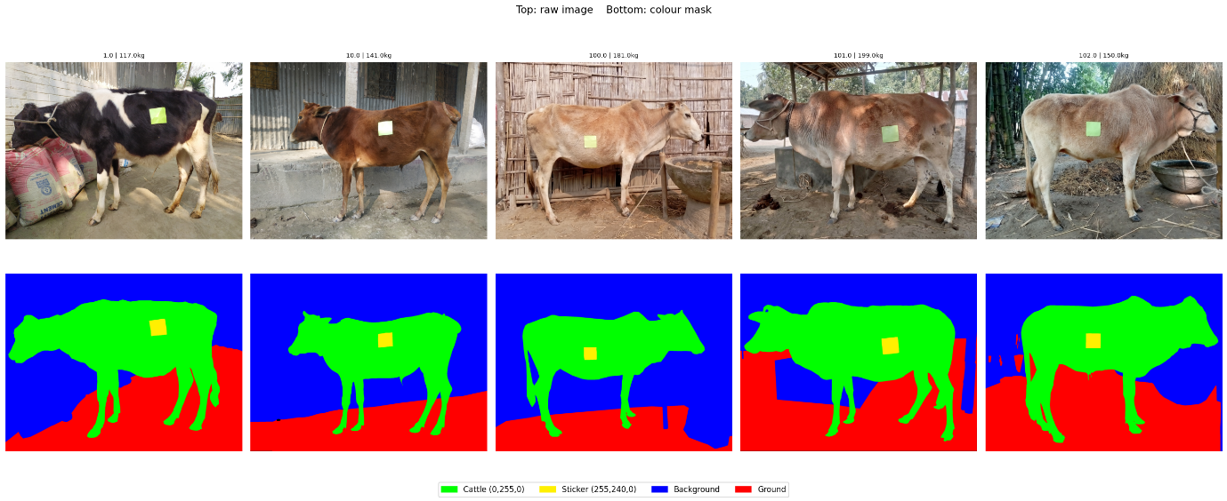
Figure 3.2: Sample CWDM colour-annotated images (top) and corresponding segmentation masks (bottom)

3.4 Scale Calibration
The physical scale is defined by a fixed capture protocol, and not per-image detection. The images of the CWDM dataset have a 10x10 cm square sticker of yellow calibration that was utilized in development to ensure that pixel-to-centimetre ratios were correct, and that measurements were repeatable throughout the dataset. This per-image scale recovery is substituted with a standardised capture distance in the deployed system by creating a cattle silhouette overlay on the capture interface. The effective focal distance is fixed by having the user align the animal into the outline and submitting the result, so the ratio of pixels per centimetre is constant with all inputs. This not only eliminates the reliance on the sticker detection completely, but also makes morphometric measurements stay within the range of scales over which the model was trained.
3.5 Morphometric Feature Extraction
Body measurement extraction follows the principle established in image-based livestock measurement literature (Tasdemir et al., 2011; Pezzuolo et al., 2018) that accurate linear measurements require isolating the body region from confounding structures such as legs and head before computing distances.
Body length is computed as the diagonal distance between two anatomical keypoints estimated from the side-view mask. Only rows where horizontal body width exceeds 70% of the maximum body width are considered, excluding head and leg regions. Within this filtered body region, point A is placed at the shoulder (column at 15% of body width from the left, bottom of trunk at that column) and point B at the pin bone (rightmost column where continuous trunk height exceeds 30 pixels, top of trunk at that column). Length is the Euclidean distance between A and B, converted to inches via the sticker scale.
Heart girth is approximated from the side-view mask as the vertical trunk height at the shoulder column (one-third from the front of the body bounding box), measured within the body region rows only to exclude leg pixels. This height is multiplied by two to account for bilateral symmetry, yielding a full girth estimate converted to inches.

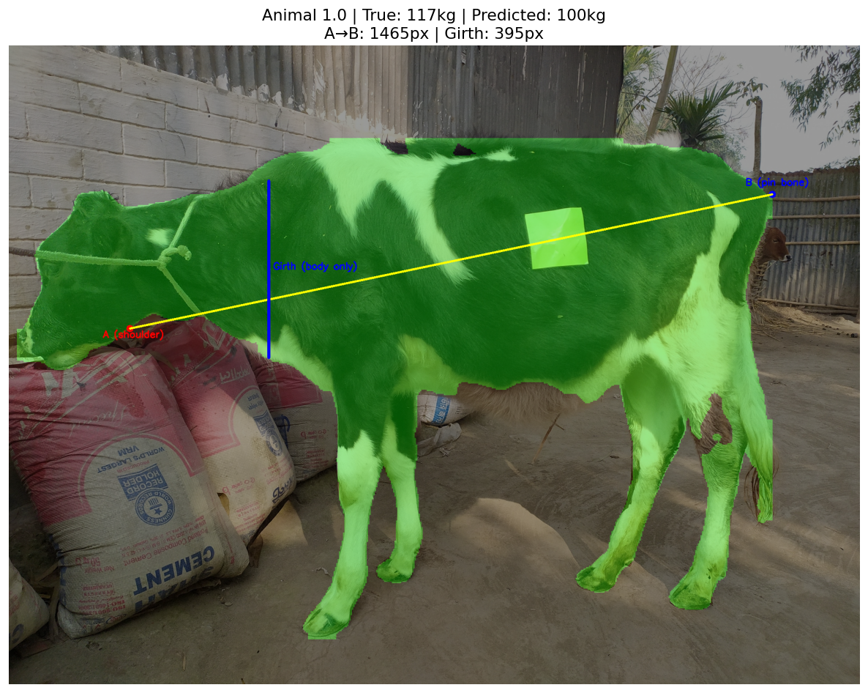
Figure 3.3: Morphometric measurement extraction showing body length (diagonal A→B) and estimated heart girth

3.6 Schaeffer Formula
The Schaeffer formula is applied using the side-view girth and diagonal body length:
Weight (lbs) = Heart Girth (in)² × Body Length (in) / 300
The result is converted to kilograms by multiplying by 0.453592. This formula was originally validated for East African zebu cattle (Lesosky et al., 2012), consistent with the CWDM dataset context.

3.7 Machine Learning Correction Layer
Twelve features are built on an image: the number of raw cattle pixels, normalized cattle area, width and height of the bounding box (raw and normalized), diagonal body length in pixels, trunk girth height in pixels, back-arc girth in pixels, aspect ratio, solidity (area divided by convex hull area), and the Schaeffer formula estimate in kilograms. The regression objective is the log-transformed weight - a common log-transformed approach in livestock weight modelling, to stabilize weight variance across the weight range (Liao et al., 2025) - and prediction is back-transformed by exponentiation at the point of evaluation. Eleven regression algorithms were tested. Five-fold cross-validation by group (i.e., with groups grouped by animal identity, GroupKFold cross-validation was used throughout to ensure that no image of the same animal appears in the training and validation splits - an essential protection in the case of a dataset that contains multiple images of the same animal (Liao et al., 2025). The final model was chosen as Ridge regression because it was cross-validated as the best model in terms of MAE.

3.8 Evaluation
Reported model performance is R 2 and Mean Absolute Error (MAE) in kilograms, calculated on back-transformed predictions to guarantee interpretability in the physical units. SHAP values obtained with the help of a LinearExplainer were calculated on the Ridge model to measure the relative contribution of each feature to each prediction (Lundberg and Lee, 2017). Ablation study subsequently introduced groupings of features to isolate the independent contribution that each component had to predictive accuracy.

Chapter 4: Demonstration/ analysis
4.1 Overview
In this chapter, the results are given in all the methods that were tested in estimating cattle weight. The main pipeline uses the Schaeffer formula on the YOLOv8 segmentation masks, which is modified by a machine learning regression layer. Two other methods CNN backbone feature extraction and body-part segmentation are tested and put into context. All findings are based on GroupKFold cross-validation based on the identity of animals to avoid data leakage among images of the same

4.2 YOLOv8 Segmentation
YOLOv8n-seg was trained on CWDM color-annotated images fine-tuned, cattle silhouettes were extracted by matching the cattle annotation color (RGB: 0, 255, 0) to a pixel tolerance of 15 units to accommodate compression artefacts. It was visually verified that proper mask production in different backgrounds and under different light conditions occurred. This pipeline requires pixel-level segmentation, as bounding boxes are not sufficient to extract morphometric measurements reliably - in line with Qiao et al. (2019), who show that contour-level masks yield much more accurate body measurements than detectors-based estimates. YOLOv8-seg was chosen compared to the other segmentation architectures based on the speed of inference, separating instances, and generalizing to agriculture. The classical encoder-decoder segmentation architecture, U-Net, is an encoder-decoder based architecture that conducts semantic segmentation, assigning a class to each pixel, but not intrinsically trying to distinguish between separate instances of animals or different body parts, which is problematic with images of multiple animals, or overlapping body parts. Mask R-CNN offers instance-level masks but is a two-stage detector, which has much higher inference latency. Sapkota et al. (2025) directly compare YOLOv8 and Mask R-CNN to instance segmentation in complex agricultural settings and note that the former is more precise and recalls more than the latter and runs at 7.810.9 ms compared to 12.815.6 ms. This benefit is also reinforced in cattle-specific designs: Araujo et al. (2025) compare both architectures to identify cattle in a variety of farm settings, with YOLOv8 at 89.8% mAP80, compared to 77.66% from Mask R-CNN, almost three times faster. In a pipeline with mask quality as the determining factor of accuracy in measurements, YOLOv8-seg provides the best trade-off between segmentation accuracy and deployability.
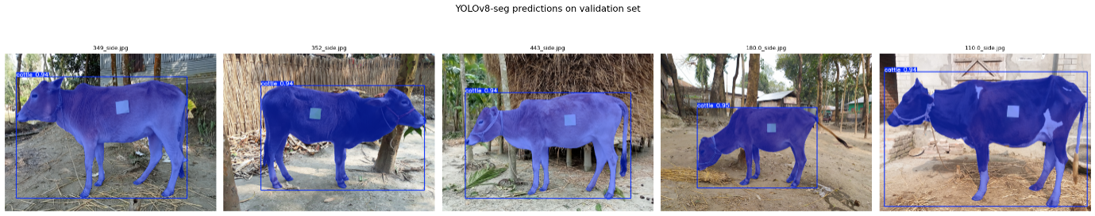
Figure 4.1: YOLOv8n-seg predicted instance segmentation masks on CWDM validation images

4.3 Method A: Pure Schaeffer Formula
The Schaeffer formula estimates live weight as:
Weight (lbs) = Heart Girth² × Body Length / 300
Heart girth was approximated as trunk height at the shoulder column (side view) multiplied by two for bilateral symmetry. Body length was measured as the diagonal distance from shoulder to pin bone, restricted to rows exceeding 70% of maximum body width to exclude the head and leg regions. A pixel-per-centimetre scale was derived from a 10×10 cm yellow calibration sticker present in each image. The formula was originally validated for East African zebu cattle (Lesosky et al., 2012), matching the geographic and breed context of the CWDM dataset.
R² = −0.120, MAE = 38.3 kg
The negative R² indicates the formula performs worse than predicting the dataset mean, confirming a systematic underestimation bias. Tasdemir et al. (2011) report the same behaviour when girth is approximated from 2D images without depth information the single-view silhouette introduces compounding measurement error within the squared girth term, making a correction layer necessary.

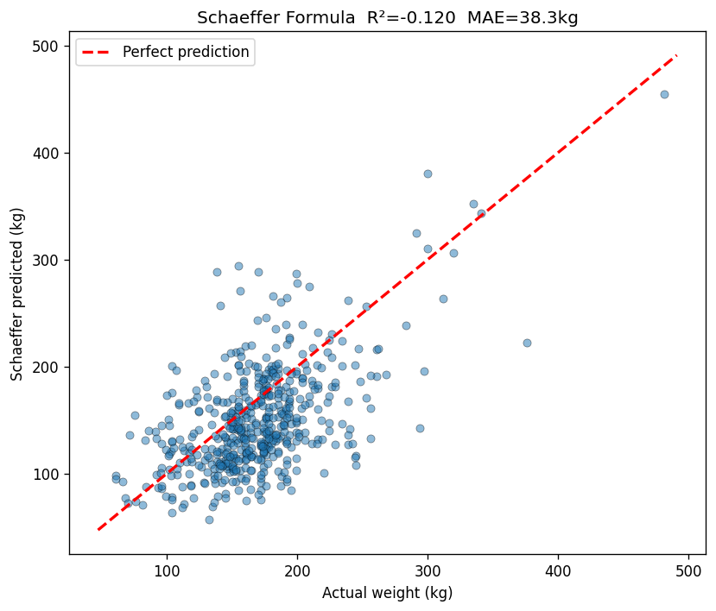
Figure 4.2: Schaeffer formula predicted vs. actual weight on CWDM dataset (R² = −0.120, MAE = 38.3 kg)

4.4 Method B: Machine Learning Correction Layer
A Ridge regression model was trained on twelve features derived from the segmentation mask: cattle pixel count, normalised area, bounding box dimensions, diagonal body length, trunk girth, back-arc girth, aspect ratio, solidity, and the Schaeffer estimate itself. The target was log-transformed weight, back-transformed via exponentiation at evaluation. Eleven regression models were evaluated.
Table 4.1: Regression model comparison (GroupKFold, 5-fold)
Model | R² | MAE (kg)
Mean baseline | ≈0.00 | ~40
Pure Schaeffer | −0.120 | 38.3
Gradient Boosting | 0.338 | 27.1
Ridge | 0.410 | 24.8
Polynomial Ridge | 0.417 | 24.5

Ridge achieved R²=0.410, MAE=24.8 kg. SHAP analysis confirmed the Schaeffer estimate as the dominant predictor, with diagonal body length and trunk girth providing secondary corrections. Polynomial Ridge offered negligible gain and was discarded given the overfitting risk at this dataset size.
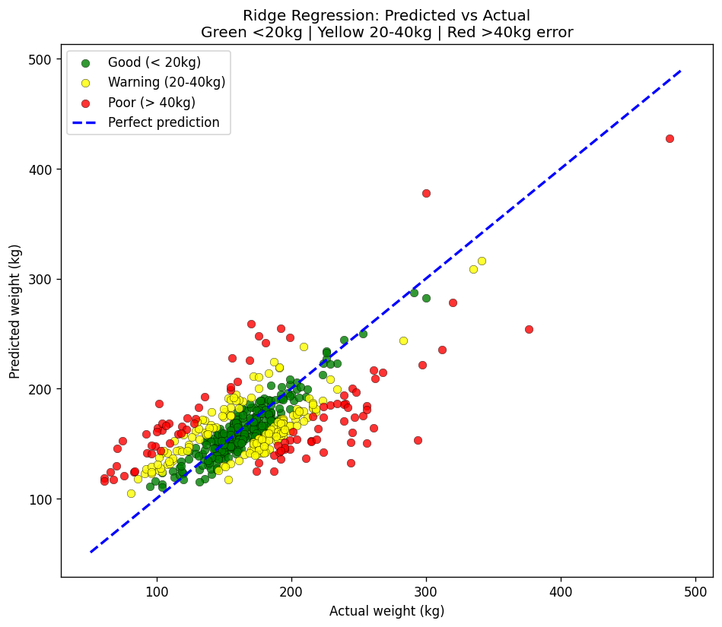
Figure 4.3: Ridge regression predicted vs. actual weight, colour-coded by error magnitude (R² = 0.410, MAE = 24.8 kg)

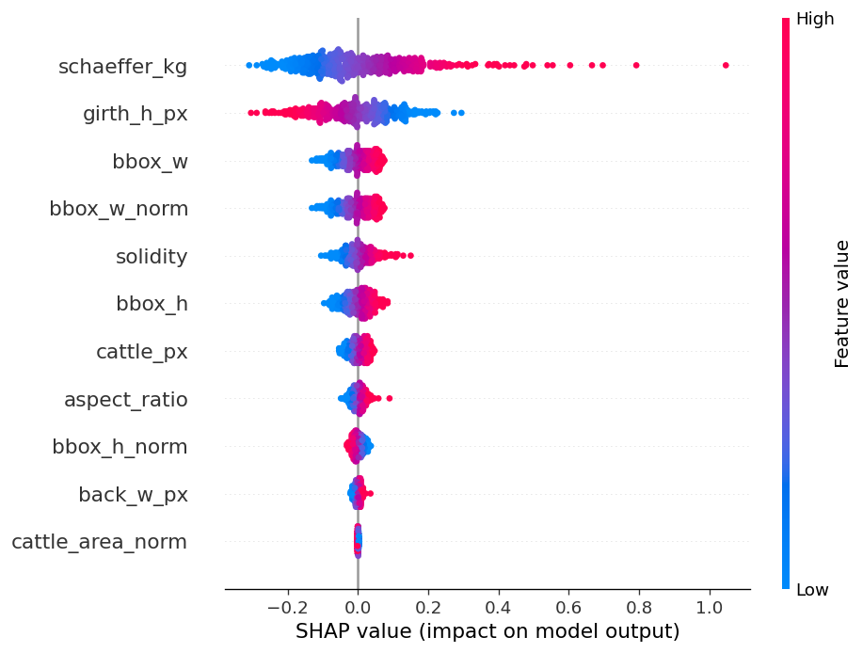
Figure 4.4: SHAP beeswarm plot showing feature importance for the ridge regression model

One practical drawback of this pipeline is that it is sensitive to camera distance. The pixel-centimeter scale factor of the calibration sticker partially accounts for distance variation, but the morphometric extraction logic, body region thresholds, trunk detection settings, and diagonal keypoint locations, were all trained on the CWDM image capture system. The model would be unable to retrain on images captured at a significantly different distance or angle and result in a decrease in measurement reliability. To handle this during deployment, this system would overlay the image capture interface with a silhouette of a cattle and the user had to align the animal with the outline before submitting the image. This limits effective camera distance and pose to the space the model was trained in, and guarantees extracted measurements are in the expected pixel scale.

4.5 Alternative Approach A: CNN Backbone Feature Extraction
As an alternative to hand-crafted measurements, a 576-dimensional feature vector was extracted per image from the YOLOv12 backbone via global average pooling. PCA (100 components) was used within each fold to control dimensionality. In testing on the CWDM data, Ridge regression gave a negative R 2, and does not extrapolate in field conditions. The identical method produced R 2 =0.735 on a different controlled-condition dataset that has height metadata information available, but height is a highly dominant predictor of weight in homogeneous conditions of the photo, indicating that this finding is due not to image feature quality but to metadata reliance. The breaking point of the CWDM outcome is evident: the raw backbone features do not have enough signal to predict weights reliably, and a lack of controlled conditions or auxiliary metadata exists
4.6 Alternative Approach B: Body-Part Segmentation
A YOLOv12-seg model was tuned to identify four anatomical categories: body (side profile), head, front legs and back legs. There were thirteen extracted normalized measurements per image, such as body area, leg span, body solidity and head-to-body ratio and averaged between images of each animal. Directly training Ridge regression on these measurements gave a negative R 2, which was worse than the mean baseline.
This is due to two reasons: the reliability of detection was not consistent among uncontrolled CWDM images so that median imputation was necessary to address missing part detections in animals; and side-view occlusion ensured that the rear leg boundaries of the images were often not complete. According to Pezzuolo et al. (2018), measurement methods of the body parts need accurate body part isolation to work, and the quality of detection is the most restrictive aspect instead of the measurement structure.
4.7 Ablation Study
Table 4.2: Feature ablation (Ridge, GroupKFold)
Feature subset | R² | MAE (kg)
Bounding box only | 0.081 | 36.7
+ Morphometric (length, girth) | 0.213 | 31.2
+ Shape descriptors | 0.298 | 28.9
+ Schaeffer estimate | 0.410 | 24.8

Each feature group contributes incrementally. The Schaeffer estimate provides the largest single gain, validating its role as a structured domain-knowledge prior that encodes geometric relationships the model cannot readily re-derive from raw pixel measurements alone.

4.8 Discussion
The ML correction layer increases the R 2 value of -0.120 to 0.410 indicating that the morphometric features that are learned can partly counteract the noise added by single-view approximations of 2D measurements. The outcome of the body-part segmentation task indicates that a clean whole-body silhouette is more useful than inaccurate part-level measurements - quality of measurements is only as good as quality of segmentation at the previous level. The backbone feature approach establishes that pretrained CNN representations are consistent with weight-relevant signal in controlled situations, yet this signal is inadequate when geometric variability is introduced by field situations and the features are not able to explain this variability. Another source of variance is the composition of the breeds - Tasdemir et al. (2011) show that when using chest girth alone the R²=0.911 with Brown Swiss cattle but only R 2 =0.607 with Holstein, indicating that a single regression model fitted to the overall breed composition in the CWDM dataset will have to accommodate radically different body proportion correlations at once.
4.9 Comparison with Related Work
Table 4.3: Comparison with published livestock weight estimation systems
Study | Method | R² / Accuracy | Sensor | Conditions
Xu et al. (2024) | ResNet-101-D segmentation + BPNN | R²=0.980 | Depth camera | Controlled barn, cattle
Jiang et al. (2024) | Mask R-CNN + XGBoost ensemble | R²=0.995 | Overhead depth | Controlled, pigs
Yue et al. (2025) | YOLOv8-Pose + 3D point cloud | <4% rel. error | Kinect V2 | Controlled, cattle
Liao et al. (2025) | YOLOv8m + XGBoost | R²=0.910 | Depth camera | Farm setting, calves
Gjergji et al. (2020) | CNN on 2D RGB images | MAE=23.19 kg | RGB only | Field, water trough
Özkaya et al. (2025) | Image analysis + polynomial regression | R²=0.920 | RGB only | Field, grazing, Simmental
This work | YOLOv8 + Schaeffer + Ridge | R²=0.410 | RGB only | CWDM field conditions

The high accuracy of studies based on depth cameras or 3D sensors is due to their ability to recover metric body measurements in the first place, eliminating the scale ambiguity of single RGB images. The closest RGB-only field study by Gjergji et al. (2020) reported MAE=23.19 kg with CNNs on dual-view images with a fixed water trough with implicitly controlled camera distance. Oskaya et al. (2025) reported R 2=0.92 when using body area measurements on images taken during regular weighing operations with a fixed camera geometry. This work has a performance gap with those studies due in part to capture geometry, but also due to an underlying limitation of determining linear body dimensions based on silhouette edges - girth and length calculated based on a 2D outline are geometric approximations and the Schaeffer formula itself has not even been reached. The R2=0.410 obtained here means that the ML correction layer is able to reconstruct some meaningful signal out of the noisy measurements, but the limit of this method is limited by the quality of the extraction of the upstream measurements and not by the regression model.
In addition to measures of accuracy, one of the main differences between these methods is the method of extracting body measurements. Measurements are directly obtained in metric space by studies based on depth cameras or Kinect sensors (Xu et al., 2024; Liao et al., 2025; Yue et al., 2025) - the physical depth of each pixel is known, so the computation of body length and girth does not require a scale calibration step. Key point models like Yue et al. (2025) can extend this to explicit anatomical features (withers, hip, chest) and then compute distances between these features, thus avoiding the problem of inferring body boundaries based on silhouette geometry. In comparison, this work and Gjergji et al. (2020) are completely RGB-based, where physical scale has to be determined indirectly, based on a calibration sticker in this case, and the fixed water-trough camera position in the case of that camera. This inherent scale recovery difference rather than the selection of the segmentation model is the key factor behind the accuracy disparity between depth-based and RGB-only methods.

Chapter 5: Project Evaluation and Reflection/ Conclusion

5.1 Contribution to Knowledge
The project shows that live weight estimation of cattle can be done with standard RGB images, in field conditions, without depth sensors or animal metadata, with the result of R2=0.410 and MAE=24.8 kg on the CWDM dataset. The main contribution is a single pipeline with YOLOv8n-seg instance segmentation, sticker-based scale calibration, Schaeffer formula estimation, and a machine learning correction layer- tested with the GroupKFold cross-validation to avoid the leakage of animal-level data. The pipeline is similar to MAE in that it is the closest field study in the literature that uses only RGB, as Gjergji et al. (2020) does, although it does not use fixed camera geometry or two-view capture infrastructure. The second contribution is systematic analysis of alternative methods CNN backbone feature extraction and body-part segmentation which both yielded negative R 2 on the CWDM dataset, which is clear empirical evidence that the methods can only be applied in controlled conditions and measure’s reliability, not the segmentation architecture. This breed diversity discovery, in line with Tasdemir et al. (2011) adds a vital contextualization of what the R 2=0.410 ceiling is: not measurement noise, but cross-breed morphological variation that a single model has to capture at the same time.
5.2 Fulfilment of Objectives
The five research questions are addressed as follows:
RQ1 — Can cattle live weight be reliably estimated from RGB images alone? Partially fulfilled. R²=0.410 demonstrates feasibility but falls short of the accuracy achieved by depth-based systems. Reliable estimation is constrained by measurement extraction quality rather than the regression methodology.
RQ2 — How accurately can the Schaeffer formula estimate weight from pixel-derived measurements? Fulfilled. R²=−0.120 confirms that the formula applied to 2D silhouette measurements introduces systematic underestimation bias, validating the need for a correction layer.
RQ3 — How does pixel-level segmentation compare to bounding box detection? Fulfilled. Consistent with Qiao et al. (2019), pixel-level contour masks produce significantly more reliable morphometric measurements than bounding box approximations, which cannot isolate individual body regions.
RQ4 — Can a scale-based calibration method provide sufficient pixel-to-metric conversion? Partially fulfilled. The sticker provides a valid scale reference within the training distribution, but a fixed capture protocol is required in deployment to ensure consistency across images.
RQ5 — Does body-part segmentation improve weight estimation over whole-body silhouette approaches? Fulfilled negatively. Body-part segmentation produced a negative R², demonstrating that unreliable part detection under field conditions degrades rather than improves measurement quality compared to a clean whole-body silhouette.

5.3 Evaluation and Reflection
The most notable weakness of the pipeline is that the quality of extraction of measurements is the binding constraint to accuracy, the ML correction layer is only capable of smoothening estimates to the extent permitted by the quality of measurements coming upstream. The geometric approximations of three-dimensional quantities are the diagonal body length and trunk girth of a 2D silhouette, and no regression model can recover all the information lost in projection. Reflectively, focusing more on measurement validation during earlier phases of the project, especially the visualization of extracted measurements as compared to ground truth, would have detected the girth formula error earlier and could have given more time to the measurement logic.
Another constraint is scope of dataset. The CWDM dataset, being geographically suitable, is an example of a local breeds distribution. It is well known that prediction accuracy differs considerably between breeds (Tasdemir et al., 2011) and the pipeline has not been tested on cow populations outside such a distribution. The standardized capture protocol the system needs also restricts the deployment flexibility - images captured outside the trained focal range will yield unreliable measurements without retraining.
5.4 Conclusion and Future Work
The project provides a functional RGB-only cattle weight estimation pipeline which can be deployed without specialized hardware and provides a practical baseline in field settings with low resources. The findings validate the claim that the Schaeffer formula can offer a useful domain-knowledge prior that can be refined by a machine learning layer, but that the accuracy limit is determined by the quality of 2D measurement extraction and not the selected regression model. Future work ought to focus on key point detection to substitute geometric approximation with body length and girth, which would be more reliable than silhouette boundary estimation by identifying anatomical landmarks directly, like the shoulder and pin bone. The height extraction of the sticker calibration scale could be automated to add a strong predictive factor without manually measuring it. Segmentation of body-parts may be considered revisited as a means of isolating the torso to apply the Schaeffer formula, instead of as a source of independent regression features. Lastly, Vision Transformers are a potential backbone architecture to fine-grained morphometric feature extraction, but their computational and data needs should be assessed against dataset size before implementation.

References
Araújo, V.M., Rili, I., Gisiger, T., Gambs, S., Vasseur, E., Cellier, M. and Diallo, A.B. (2025) ‘AI-powered cow detection in complex farm environments’, Smart Agricultural Technology, 10, p.100770.
Bewley, J.M., Peacock, A.M., Lewis, O., Boyce, R.E., Roberts, D.J., Coffey, M.P., Kenyon, S.J. and Schutz, M.M. (2008) ‘Potential for estimation of body condition scores in dairy cattle from digital images’, Journal of Dairy Science, 91(9), pp.3439–3453.
Gjergji, M., Weber, V.A.M., Silva, L.O.C., Gomes, R.C., Araújo, T.L.A.C., Pistori, H. and Alvarez, M. (2020) ‘Deep learning techniques for beef cattle body weight prediction’, Proceedings of the 2020 International Joint Conference on Neural Networks (IJCNN), Glasgow, UK, pp.1–8.
Jiang, B., Tao, T., Shu, J., Wu, J., Li, X. and Wang, Z. (2024) ‘Pig weight estimation method based on a framework combining Mask R-CNN and ensemble regression model’, Animals, 14(14), p.2040.
Jocher, G., Chaurasia, A. and Qiu, J. (2023) Ultralytics YOLO [Computer software]. Available at: https://github.com/ultralytics/ultralytics (Accessed: 21 April 2025).
Lesosky, M., Dumas, S., Conradie, I., Handel, I.G., Jennings, A., Thumbi, S., Toye, P. and de C Bronsvoort, B.M. (2012) ‘A live weight–heart girth relationship for accurate dosing of East African shorthorn zebu cattle’, Tropical Animal Health and Production, 44(4), pp.911–916.
Liao, Y., Clark, C.C.T., Yao, J., Hu, Z. and Yang, X. (2025) ‘Predicting dairy calf body weight from depth images using deep learning (YOLOv8) and threshold segmentation with cross-validation and longitudinal analysis’, Animals, 15(6), p.862.
Lin, T.Y., Maire, M., Belongie, S., Hays, J., Perona, P., Ramanan, D., Dollár, P. and Zitnick, C.L. (2014) ‘Microsoft COCO: Common objects in context’, Lecture Notes in Computer Science, 8693, pp.740–755.
Lundberg, S.M. and Lee, S.I. (2017) ‘A unified approach to interpreting model predictions’, Advances in Neural Information Processing Systems, 30, pp.4765–4774.
Machila, N., Fèvre, E.M., Maudlin, I. and Eisler, M.C. (2008) ‘Farmer estimation of live bodyweight of cattle: implications for veterinary drug dosing in East Africa’, Preventive Veterinary Medicine, 87(3–4), pp.395–403.
Oka, A.A., Sarini, N.P., Swastika, P.V. and Dharmawan, K. (2025) ‘Choosing the best machine learning model for weight estimation at different growth stages in Bali cattle’, Asian Journal of Dairy and Food Research, 44(5), pp.831–837.
Özkaya, S., Bozkurt, Y. and Tüzün, G. (2025) ‘Estimation of live weight from 2D digital images of Simmental cattle grazing in Kars Province’, Journal of Animal Science and Products, 8(2), pp.84–91.
Pezzuolo, A., Guarino, M., Sartori, L., González, L.A. and Marinello, F. (2018) ‘On-barn pig weight estimation based on body measurements by a Kinect v1 depth camera’, Sensors, 18(2), p.364.
Qiao, Y., Truman, M. and Sukkarieh, S. (2019) ‘Cattle segmentation and contour extraction based on Mask R-CNN for precision livestock farming’, Computers and Electronics in Agriculture, 165, p.104958.
Sapkota, R., Ahmed, D. and Karkee, M. (2025) ‘Comparing YOLOv8 and Mask R-CNN for instance segmentation in complex orchard environments’, Artificial Intelligence in Agriculture, 11, pp.29–40.
Tasdemir, S., Urkmez, A. and Inal, S. (2011) ‘Determination of body measurements on the Holstein cows using digital image analysis and estimation of live weight with regression analysis’, Computers and Electronics in Agriculture, 70(1), pp.60–67.
Xu, B., Mao, Y., Wang, W. and Chen, G. (2024) ‘Intelligent weight prediction of cows based on semantic segmentation and back propagation neural network’, Frontiers in Artificial Intelligence, 7, p.1299169.
Yue, C., Zhang, X., Zhang, Y., Jiang, H. and Miao, H. (2025) ‘Automatic and accurate measurement of cattle body based on a lightweight YOLOv8-Pose model and 3D point cloud’, Machine Learning with Applications, 20, p.100607.
Zin, T.T. and Tin, P. (2026) ‘Computer vision in precision livestock farming: artificial intelligence-driven technologies and applications for sustainable animal production’, Animal Bioscience, 39(3), pp.391–405.

Table of Abbreviations
- CWDM – Cattle Weight Detection Model Dataset

Appendix A: Codes and Files
Link to data sets, codes, and files.

Appendix B: Supervisory meeting and emails.
Provide a table that include details regarding the communication with your supervisor/ module leader
Date/ Time | Type of communication | Actions
Add Date/time | Online meeting | [Add set of actions ]
 | F 2F meeting
 | Email

[You may increase the number of rows as needed]

Appendix C: ------

